Running INOVA Software in Administrator Mode

## Introduction:

All INOVA software must be run in Administrator mode.

## Steps to do:

1. Right click on the software icon (either on the desktop or in Executable Application file in program files)

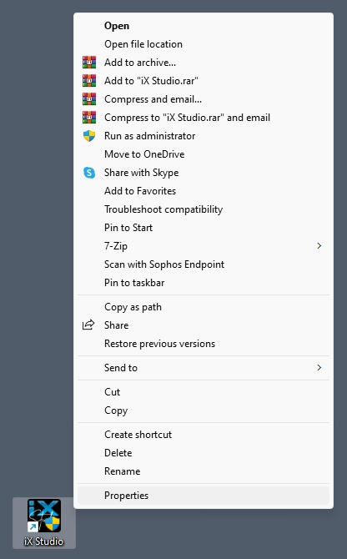

2

1. Click on “Properties”
2. Select “Compatibility”

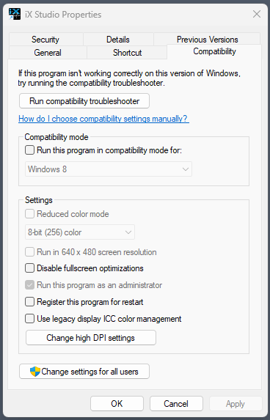

6

5

4

3

1. Select “Run this program as an administrator”
2. Click “Apply”.
3. Click “OK”.

---------------------------------------------------------End----------------------------------------------------------